**20 Questions**

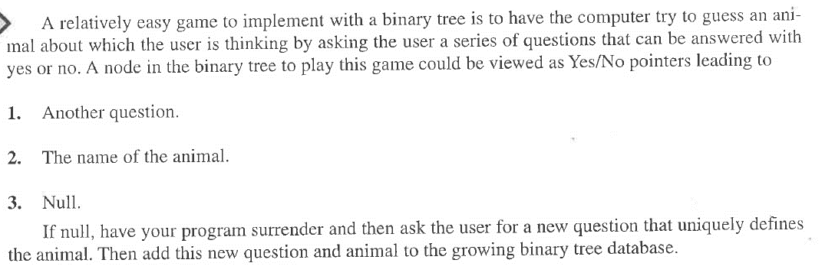

You may select any topic for this project. If you want to use animals as the topic, you can find a list of common zoo animals here: <https://www.thetoptens.com/zoo-animals/>

Your program should start with the first question and two answers, such as the one below. Then, the program should grow as the user plays the game.

With the above question, the program will ask the user "Find at Zoo?" then, depending on the answer, we will navigate to the right or left of the tree. If we are **not** at a leaf node, we are at a question. In this case we ask the question and move left or right in the tree as appropriate. When we reach a leaf node, we are at an answer so we make a guess. If our guess is correct, we indicate we guessed the animal and ask the user if he would like to play again. If we guess incorrectly, we ask the user for the animal they were thinking of and a question that uniquely defines their animal. We then add the user provided question to the node storing the incorrectly guessed animal and place the incorrectly guessed animal as its left child and the user provided animal (the correct one) as its right child. See example input/output.

EXAMPLE INPUT/OUTPUT (user input in **bold**)

Find at Zoo? **Yes**

Elephant? **Yes**

I guessed it!

Would you like to play again? **Yes**

Find in Zoo? **Yes**

Elephant? **No**

What is your animal? **Dolphin**

Provide a question that uniquely identifies your animal? **Lives in water?**

Would you like to play again? **Yes**

At this point the tree looks as indicated below. The game continues until the user indicates he does not want to play again.